Uploading “Word” documents from a Chromebook
Step 1:
Visit www.google.com
Step 2:
In the top right hand corner, click on the block image next to “Images”
Step 3:
Select “Drive”
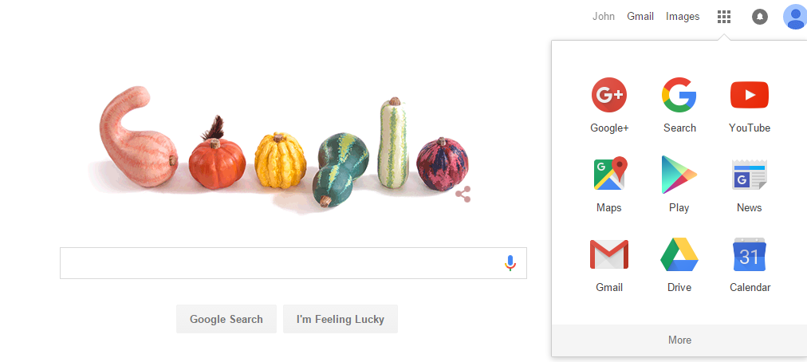
Step 4:
The options shown below are on the left side of the screen. You will select “New” in red.
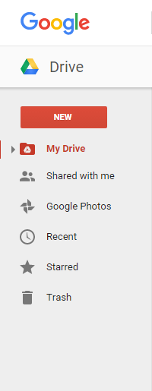
Step 5:
Once in “New”, you will select “Google Docs”.
Step 6:
At the top left hand corner, name your document (name it appropriately; the title is what is submitted).
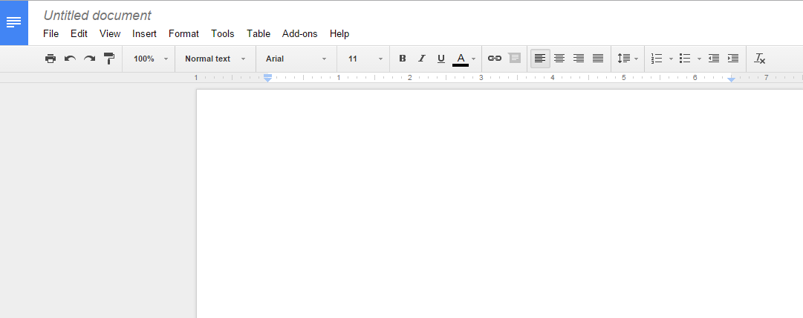
Step 7:
Type out your assignment in the content box like you would in Microsoft Word or Open Office.
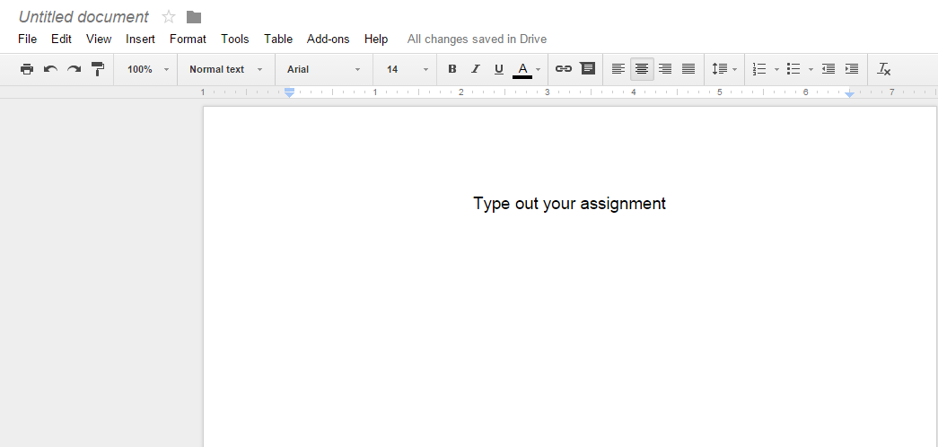
Step 8:
When assignment is complete and you are ready to save……..
- select “File”
- “Download As”
- “Microsoft Word (.docx)”
Step 9:
Now enter the course and select the lesson linked to the assignment.

Step 10:
Once you are in the lesson, return to the question where the assignment needs to be uploaded. Select the “Attach File” button.

Step 11:
Then select the title of the document you just created to be uploaded.
Step 12:
Make sure you “submit” the lesson once the attachment is uploaded.

